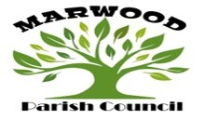

e:mail marwoodclerk@outlook.com
www.marwoodparishcouncil.co.uk

NOTICE

Parish Councillors Vacancies
Marwood Parish Council currently have three vacancies for Parish Councillors. For more information or to express an interest please contact

marwoodclerk@outlook.com

